30.01.2023 Assignment

February 15, 2023


[1]: #Programe to Display Grades

# Ans :- 1

a = int(input('Please Enter The Percentage here :- '))

if a < 60 :

print | ('Grade is D')
if 60 <= a <=80 :
print | ('Grade is C')
if 80 < a | <=90 :
print | ('Grade is B')
if 100 > a > 90 :
print | ('Grade is A')
Please Enter The Percentage here :- |  | 75
Grade is C
[2]: #Programe | to Display the Road-Tax
# Ans - 2

cost_price = int(input('Please Enter the cost price of Bike'))

if cost_price > 100000:

print('Road-tax is ',0.15*cost_price)

if 50000 < cost_price <= 100000:

print('Road-tax is ',0.10*cost_price)

if cost_price <= 50000:

print('Road-tax is ',0.05*cost_price)

Please Enter the cost price of Bike 55000

Road-tax is 5500.0

[3]: #Programe to Display the Monument

# Ans - 3

city = input('Please Enter the city name here ')

if city == 'delhi' :

print('Red-Fort')

if city == 'agra' :

print ('Taj-mahal')

if city == 'jaipur':

print('Jal-mahal')

1

Please Enter the city name here agra

Taj-mahal


[4]: #Check how many times a given number can be divided by 3 before it is less than␣ ↪or equal to 10.
# Ans - 4
x = int(input('Enter the number'))

q = (x-10 )// 3

q

Enter the number 50

[4]: 13


[5]: #Why and When to Use while Loop in Python give a detailed description with␣ ↪example
#Ans - 5 Python while loop is used to run a block code until a certain␣ ↪condition is met.
i = 1

while i < 6:

print(i)

i += 1

1

2

3

4

5
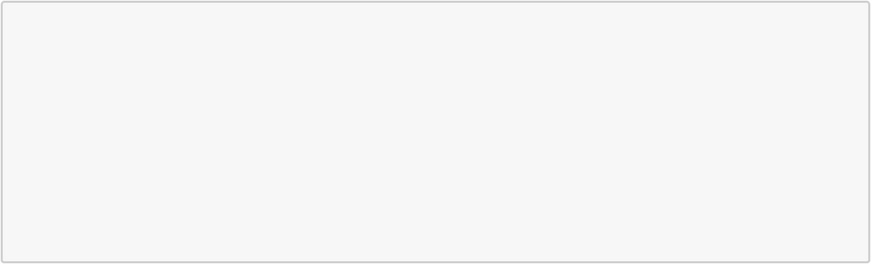

[6]: #Use nested while loop to print 3 different pattern.

#Ans - 6

i=1

while i<=5:

j=1

while j<=i:

print(j,end=" ")

j=j+1

print("")

i=i+1

1

- 2

- 2 3

- 2 3 4

- 2345

2


[7]: #Reverse a while loop to display numbers from 10 to 1.

#Ans - 7 & 8

x = 10

while (x > 0):

print(x)

x -= 1

10

9

8

7

6

5

4

3

2

1

[ ]:

3

